How to create Trace/Log file?

# Step 1

Shutdown all Visual Studios

# Step 2

Set environment variable using control panel->System->Advanced setting (see screen shot below)

UCINETTRACE=c:\temp

UCINETTRACESWITCH=4

A file will be created in c:\temp\ ucinet_trace_???.txt

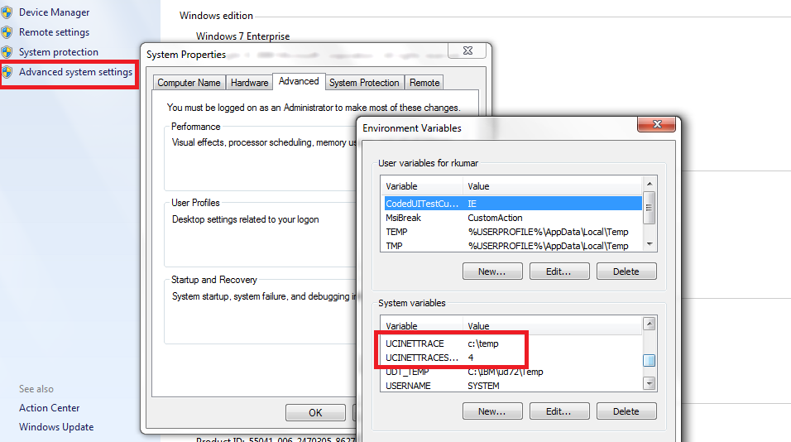

# Step 3

Start Visual Studio and collect Log/Trace file c:\temp\ ucinet_trace_???.txt